PACKET OUTLINE (STUDY GUIDE): SEAFLOOR SPREADING, PANGEA and THE THEORY OF PLATE TECTONICS

- The theory of plate tectonics states that the lithosphere is broken into plates that have always been in constant motion. It is built upon the ideas of CONTINENTAL DRIFT put forth by Alfred Wegener in the early 1900s.

- EVIDENCE TO SUPPORT THE THEORY OF PLATE TECTONICS comes from a variety of sources:
    - Mesosaurus fossils that could not swim in salt water but were found on widely separated landmasses, such as South America and Africa. They were most likely on the same landmass (Pangea) BEFORE it split apart.
    - From mountain ranges at the edges of South America and Africa continents which are all made from the same types of rocks, oriented in the same direction
    - From glacial scrape marks on continents that are now too close to the equator to sustain glaciers
    - From the age of rocks on the seafloor. Young rocks sandwiched between older ones indicate the older ones moved apart to make room for incoming magma.
    - From magnetic anomalies, showing periods of normal and reversed polarity on each side of the mid-ocean ridge. Patterns on the left match patterns on the right side, indicating that the ridge material split apart at the center.

- DIVERGENCE is when plates move apart:
- Oceanic plates separate, exposing the mantle underneath. Magma rises from the asthenosphere, melts by decompression and flows in the gap between the plates. When it cools it hardens, creating new crust (basalt rock). The ocean floor pulls apart again, and the process repeats.
- The new rocks appear as a MID-OCEAN ridge or rift valley
- The Seafloor grows or spreads
- The Mid-Atlantic ridge is an example of a divergent boundary
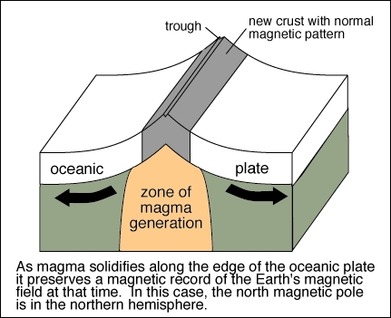
- Divergence allows for the creation of new seafloor
- Seafloor spreading is the mechanism for continental drift and the break up of Pangea. When the seafloor moves outward from the ridge, they push the continents apart
- Convection currents under the lithosphere move the plates apart.

- NORMAL AND REVERSE POLARITY
  - Earth’s north and south poles act as a giant magnet.
  - As magma at the divergent boundary solidifies to form new rock, iron rich minerals in the magma align with earth’s magnetic field, indicating the direction of magnetic north at the time when the magma cooled. This forms a kind of magnetic signature, preserved in the basalt.
  - The direction of earth’s magnetic field can be
    - NORMAL- where magnetic north is in northern hemisphere. This is also called a POSITIVE ANOMALY
    - REVERSED- where magnetic north is closer to the present day south pole. This is also called a NEGATIVE ANOMALY

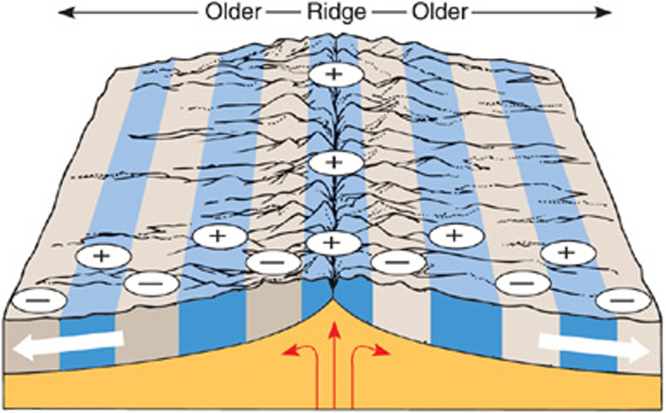

  - ALL ROCKS THE SAME DISTANCE FROM THE MID-OCEAN RIDGE HAVE THE SAME AGE AND THE SAME POLARITY (anomaly) because they were formed at the same time
  - In the diagram above, there have been 5 magnetic reversals (you only count one side since the other side of the ridge was formed at the same time)

- CONVERGENCE is when plates collide with each other. There are three types of convergence:
  - OCEANIC-CONTINENTAL CONVERGENCE occurs when an oceanic plate collides with a continental plate.
    - The oceanic plate SUBDUCTS under the continent, BECAUSE IT IS MORE DENSE, creating a subduction zone.
    - The oceanic plate MELTS into magma as it subducts into the asthenosphere
    - A TRENCH is formed at the place where the two plates meet because the oceanic crust subducts at an angle
    - A VOLCANO forms at the edge of the continent

  - OCEANIC-OCEANIC CONVERGENCE occurs when two oceanic plate collide.
    - A trench and a volcano are still produced

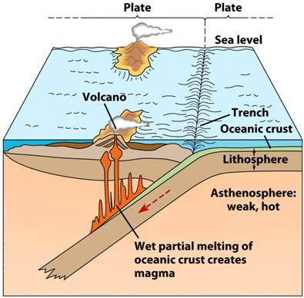

  - CONTINENTAL-CONTINENTAL CONVERGENCE occurs when two continental plates collide. Only MOUNTAINS are formed. They are NOT volcanoes

- TRANSFORM BOUNDARY is formed when two plate slide past each other.
  - The San Andreas fault is a major example of this type of boundary
  - Earthquakes are associated with transform boundaries
